**FPT ACADEMY INTERNATIONAL FPT – APTECH COMPUTER EDUCATION**

**Centre Name: ACE-HCMC-2-FPT.**

**Address: 590 Cach Mang Thang 8, District 3, Ho Chi Minh City, Viet Nam.**

**Incredible Bridges**

|  |  |  |
| --- | --- | --- |
| **Supervisor:** | Ms. Le Mong Thuy |  |
| **Semester:** | 1 |  |
| **Batch No:** | T1.2406.E1 |  |
| **Group No:** | 6 |  |
| **Order:** | **Name** | **Student ID** |
| **1.** | Bui Anh Khoa | Student1581877 |
| **2.** | Nguyen Minh Thuc | Student1580660 |
| **3.** | Ngo Tuan Anh | Student1575994 |

Date: September- 2024

# This is to certify that

**Mr.** Bui Anh Khoa

**Mr.** Ngo Tuan Anh

**Mr.** Nguyen Minh Thuc

# have successfully designed & developed:

eProject: Incredible Bridges

# Submitted by:

Mr. Le Mong Thuy

**Date of issue:** Sep 26th 2024

# Authorized Signature

**Table Content.**

ACKNOWLEDGMENT 4

SYNOPSIS 4

ANALYSIS 4

1. Purpose of the Website 4

2. Design and Interface 4

3. Technical Requirements 4

CUSTOMER'S REQUIREMENTS SPECIFICATIONS 5

1. Business/Project Objective 5

**Hardware/Software Requirements** 5

SCOPE OF THE WORK (IN BRIEF) 5

1. Home 5

2. Bridges Categorization 6

3. Gallery 6

4. Contact 6

5. Technical Requirements 6

DIAGRAM OF THE WEBSITE 7

ARCHITECTURE AND DESIGN OF THE SYSTEM 8

TASK SHEET REVIEW 1 9

SITE MAP 10

MOCK OF THE WEBSITE 11

**1.** **Home** 11

**2.** **Bridges, Category (Historical Great Bridges, Iconic Bridges, Morden Great Bridges, High-Level Achievement Bridges), Continent Filter(Asia, Europe, Africa, North America, South America, Oceania) :** 11

**3.** **About Us** 14

**4.** **Feeback** 14

**5.** **Gallery** 15

**6.** **Site Map** 15

**7.** **Contact (Pop-up Model)** 16

TASK SHEET REVIEW 2 16

WEBSITE DESCRIPTION 18

**1.** **Home** 18

**2.** **Header** 18

**3.** **Top Page** 18

**4.** **Category** 19

**5.** **Continent Filter** 19

**6.** **List of Bridges** 20

**7.** **Each Bridge Detail** 20

**8.** **Contact** 22

**9.** **About Us** 23

**10. Footer** 23

TASK SHEET REVIEW 3 25

# ACKNOWLEDGMENT

On behalf of team members, I would like to thank everyone who supported my team to successfully complete this eProject report. Especially, our teacher, who has supported us a lot since we started studying at FPT Aptech. With this eProject, she guided us very meticulously, enthusiastically, and strictly. With her guidance, we were able to successfully complete this project. Besides, I also want to thank all the team members, each of whom worked hard to complete the eProject in earnest during the month of working together. Finally, our group would like to say thank you to my classmates and family for sharing and creating the best environment for the group to focus on the project, motivating the members to achieve their goals.

# SYNOPSIS

Mankind has been building bridges since the time of early civilizations. Today, bridges are all around us – they provide easier, faster, and safer connections between two points. Bridges have evolved from merely utilitarian structures to become symbols of cities, countries, and human progress. Iconic bridge structures embody engineers’ eternal aspiration to greater achievement – longer and taller, stronger and faster. We all admire bridges that span gracefully over a deep ravine, canyon, large river, or bay, and rightfully consider them high technical achievements.

Today’s bridges not only symbolize our world’s advancement in design but its advancement in technology as well. Consequently, architects and engineers have been able to merge design and technology together to create bridges that are bigger, better, and more spectacular than ever before. Several of these are simply stunning – a true marvel of classic engineering capabilities and the outstanding achievements of modern engineering.

We are supposed to compile the world’s most incredible bridges, both young and old. You are supposed to create a Single-Page Application and a responsive website for them with the below-mentioned requirement specifications. The website should work well in all leading browsers including Chrome, IE, Firefox, etc.

# ANALYSIS

1. Purpose of the Website  
   The website was developed to provide comprehensive and reliable information about incredible bridges worldwide. It features detailed descriptions of various bridges, focusing on their construction, significance, and the innovative technologies behind them. The site also highlights the engineering challenges these structures address and the aesthetic qualities that make them iconic.
2. Design and Interface  
   The website offers a user-friendly experience with an intuitive navigation system. The layout features essential information on various types of bridges, and the content is designed to be visually engaging with a harmonious color scheme.

## Technical Requirements

* + The website must perform well across all major browsers including Chrome, IE, Firefox, etc., ensuring accessibility from various devices and platforms.
  + It utilizes a Single-Page Application (SPA) approach to deliver a seamless and fast web browsing experience.
  + Features are designed to meet technical requirements, facilitating quick and accurate loading and display of information.

# CUSTOMER'S REQUIREMENTS SPECIFICATIONS

**Client:** APT India Co.

1. Business/Project Objective  
   The portal will be designed as a Single-Page Application and a responsive website with a set of pages and menus that represent choices of activities to be performed. The pages, menus, and other visual elements must be designed in a visually appealing manner with attractive fonts, colors, and animations. All of these should also be laid out in a responsive manner.

**The website is to be created based on the following requirements:**

* 1. The top of the page should be presented with a suitable logo and various images of famous bridges.
  2. The site should have sections like Historical Great Bridges, High-Level Achievements in Bridges, Iconic Bridges, Modern Great Bridges, etc.
  3. Sections like Longest, Tallest, Highest, Oldest, etc., should be added to the website.
  4. History and information of the bridges should be added along with images.
  5. The site must contain a filter based on continents to look for various bridges in each continent.
  6. A gallery can be added for viewing different images.
  7. Feedback must be allowed to be entered by the viewer.
  8. A site map, gallery, about us, FAQ link, and contact us link must be added.
  9. The "About Us" and "Contact Us" sections should display the email ID, address, and contact number of the organization developing the system.
  10. The advertisement section for buses and flights can be included for reaching the location.

## **Hardware/Software Requirements**

**Hardware:**

* Intel Core i3/i5 Processor or higher
* 8 GB RAM or above
* Color SVGA
* 500 GB Hard Disk space
* Mouse
* Keyboard

**Software:**  
**Technologies to be used:**

* Frontend: HTML5, CSS, Bootstrap, JavaScript, jQuery, React/AngularJS, Figma, XML
* Data Store: JSON files or TXT files

**Other Requirements:**

* Operating Portal: Windows
* Browsers: Edge, Chrome, Mozilla Firefox, Safari

# SCOPE OF THE WORK (IN BRIEF)

## Home

* + Overview of incredible bridges and a brief introduction.
  + Outstanding Bridges (biggest, highest, etc.): Bridges filtered based on size such as tallest, biggest, closest, etc.

## Bridges Categorization

* + **Historical Bridges:** Provides information about bridges constructed a long time ago.
  + **Iconic Bridges:** Provides information about bridges considered iconic worldwide.
  + **Continent filter:** Categorizes bridges based on location, divided by continent (NA, Africa, Asia, etc.).
  + **High-Level Achievements Bridges**

## Gallery

* + **Images:** A photo gallery featuring incredible bridges.

1. Contact**:** Contact information for users to reach out or send feedback.
2. Technical Requirements: Utilizing technologies such as HTML5, CSS3, JavaScript, React, JSON, Bootstrap, and the MUI (Material-UI) library to ensure a smooth user experience across popular browsers such as Chrome, Firefox, and Edge.

# DIAGRAM OF THE WEBSITE

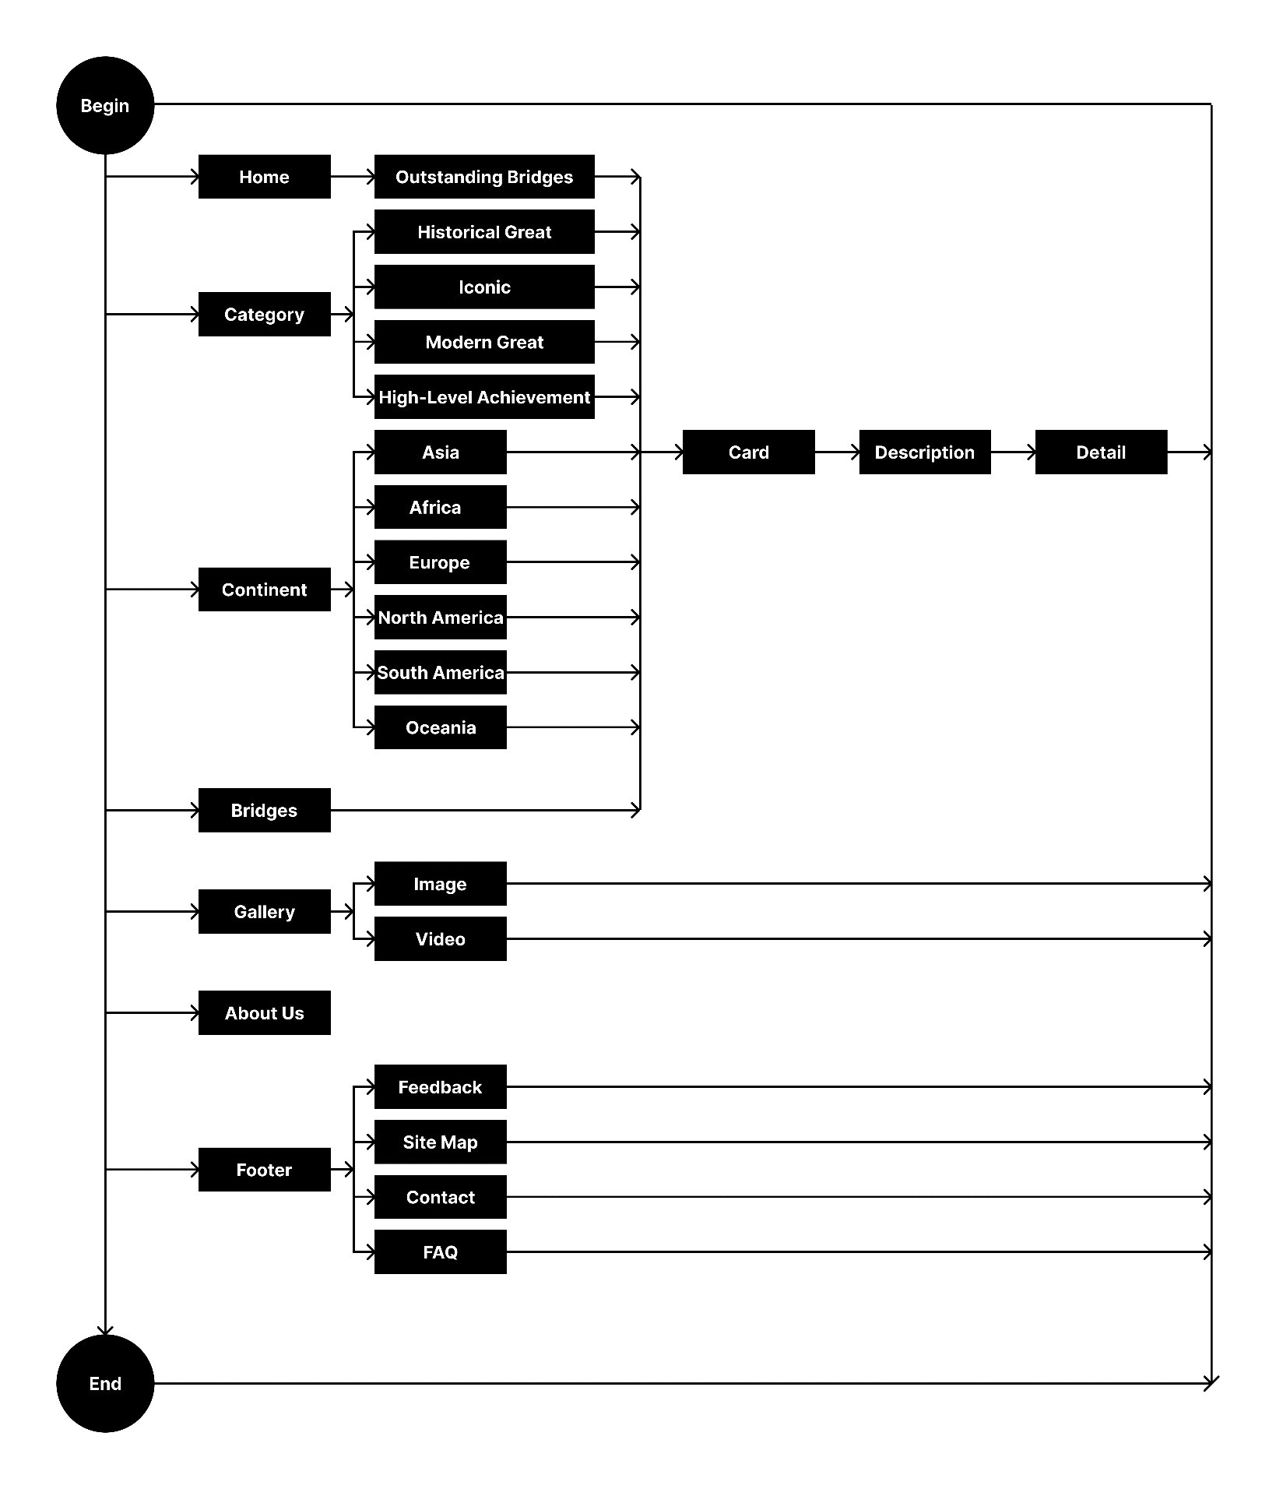

# ARCHITECTURE AND DESIGN OF THE SYSTEM

Webpage request

**CLIENT**

**WEB BROWSER**

**SERVER**

**WEB SERVER**

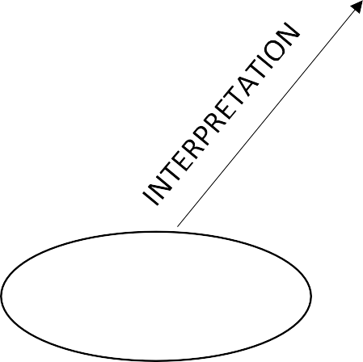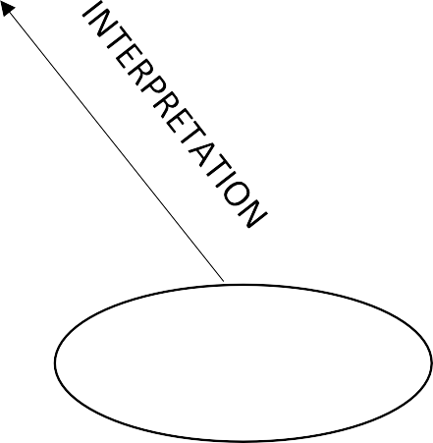

Requested Page

**RENDERING**

**ENGINE**

**CSS CODE**

**HTML CODE**

# TASK SHEET REVIEW 1

**Project Title:** Incredible Bridges  
**Activity Plan Prepared By:** Nguyen Minh Thuc

|  |  |  |  |  |  |  |
| --- | --- | --- | --- | --- | --- | --- |
| Sr. No | Task | Date of Preparation of Activity Plan | Actual Start Date | Actual Days | Team Mate Names | Status |
| 1 | Synopsis | 01/10/2024 | 29/09/2024 | 1 | Bui Anh Khoa | Completed |
| 2 | Analysis | 01/10/2024 | 29/09/2024 | 2 | Ngo Tuan Anh | Completed |
| 3 | Scope of Work (Summary) | 01/10/2024 | 29/09/2024 | 2 | Nguyen Minh Thuc | Completed |
| 4 | Design of Website Interface | 01/10/2024 | 01/10/2024 | 2 | Ngo Tuan Anh | Completed |
| 5 | Research Information on Bridges | 01/10/2024 | 29/09/2024 | 2 | Ngo Tuan Anh | Completed |
| 6 | Architecture and System Design | 01/10/2024 | 30/09/2024 | 2 | Nguyen Minh Thuc | Completed |
| 7 | Website Sitemap | 01/10/2024 | 01/10/2024 | 2 | Bui Anh Khoa | Completed |
| 8 | Assist with Report Preparation | 01/10/2024 | 02/10/2024 | 1 | Bui Anh Khoa | Completed |
| 9 | Task Sheet Review | 01/10/2024 | 03/10/2024 | 1 | Nguyen Minh Thuc | Completed |

|  |  |
| --- | --- |
| **Date:** | |
| Signature of Instructor:  **Le Mong Thuy** | Signature of Team Leader:  **Nguyen Minh Thuc** |

# SITE MAP

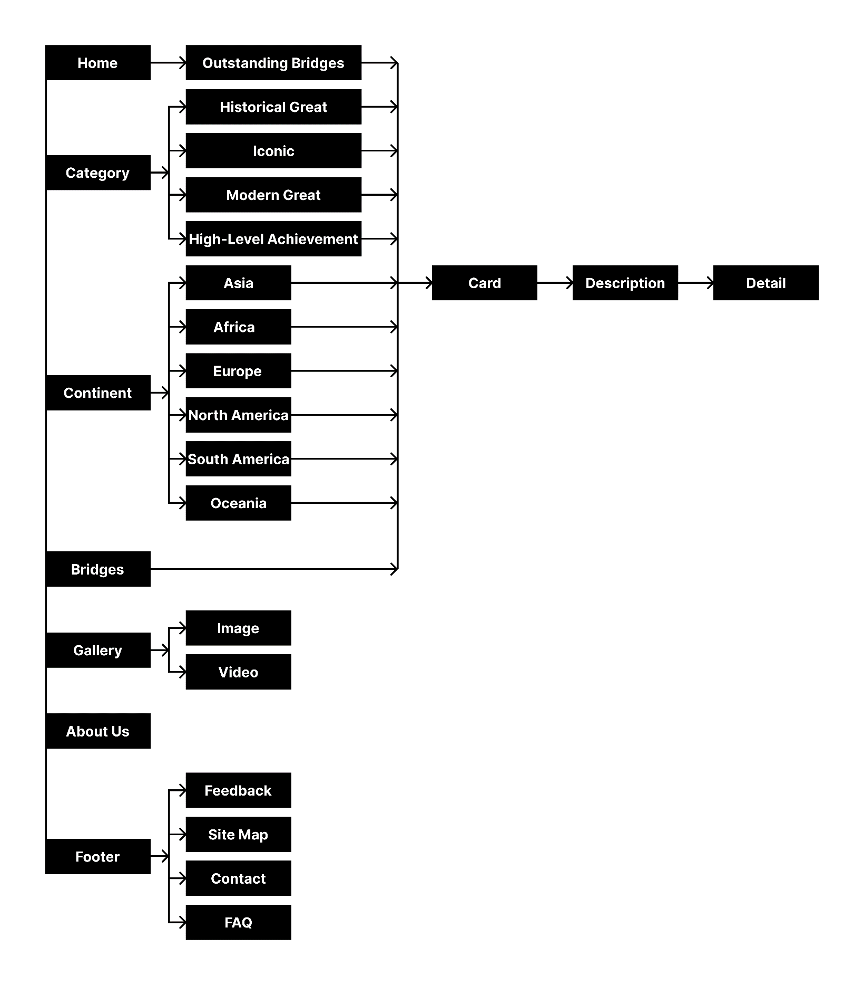

# MOCK OF THE WEBSITE

## **Home**

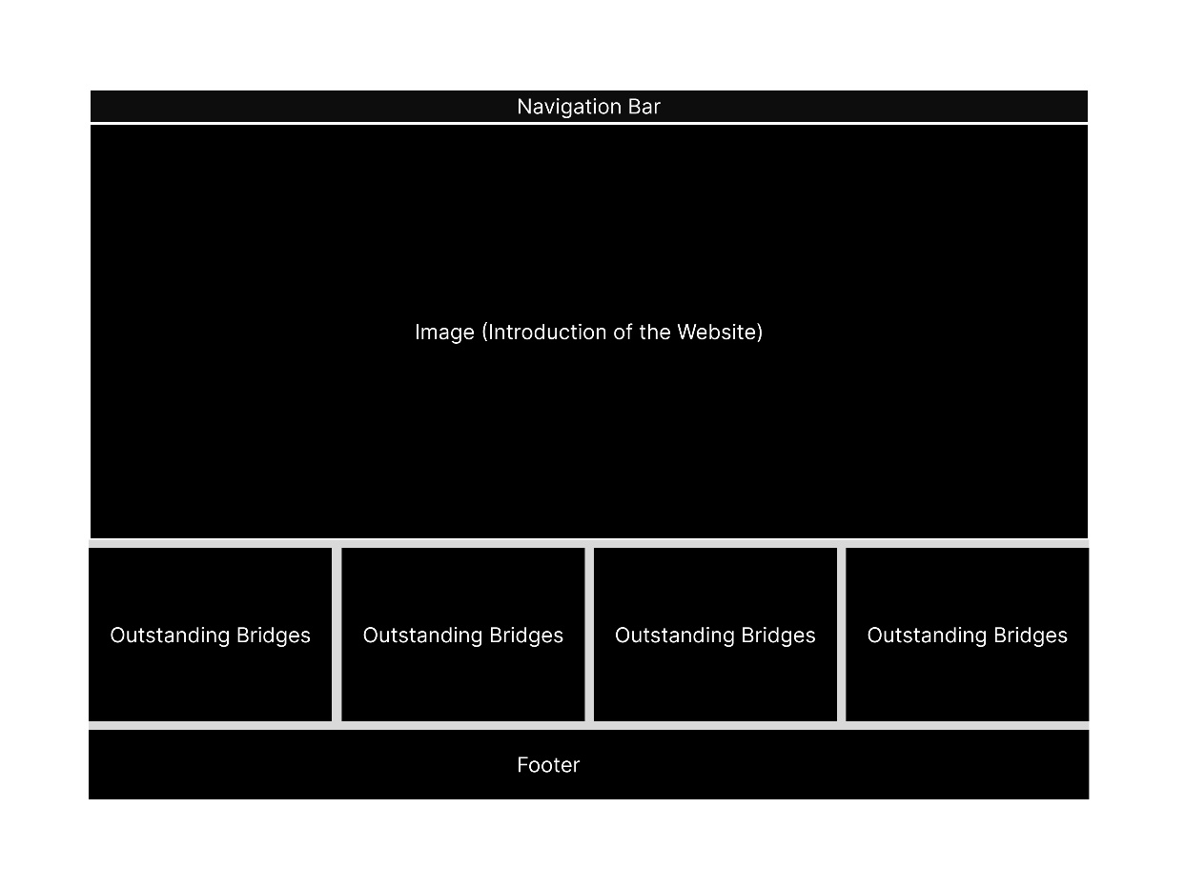

## **Bridges, Category (Historical Great Bridges, Iconic Bridges, Morden Great Bridges, High-Level Achievement Bridges), Continent Filter(Asia, Europe, Africa, North America, South America, Oceania) :**

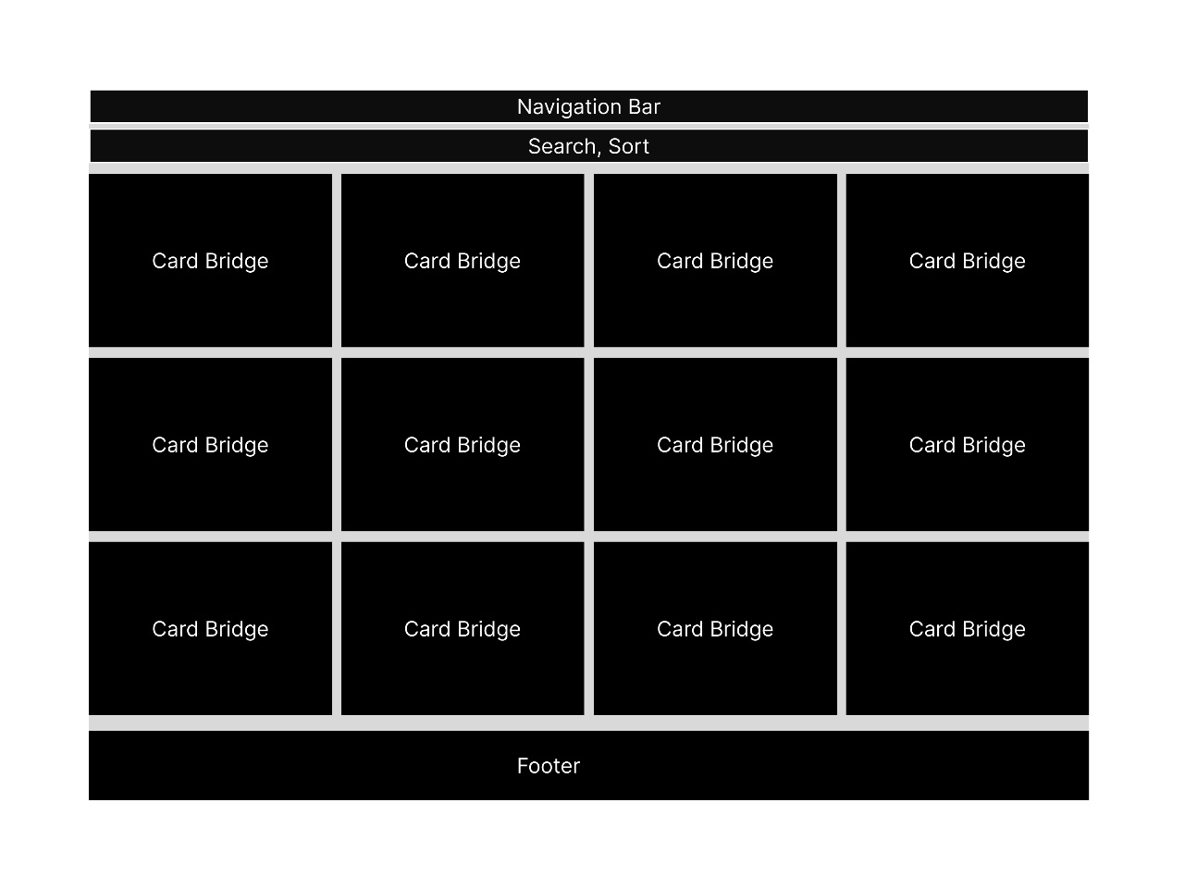

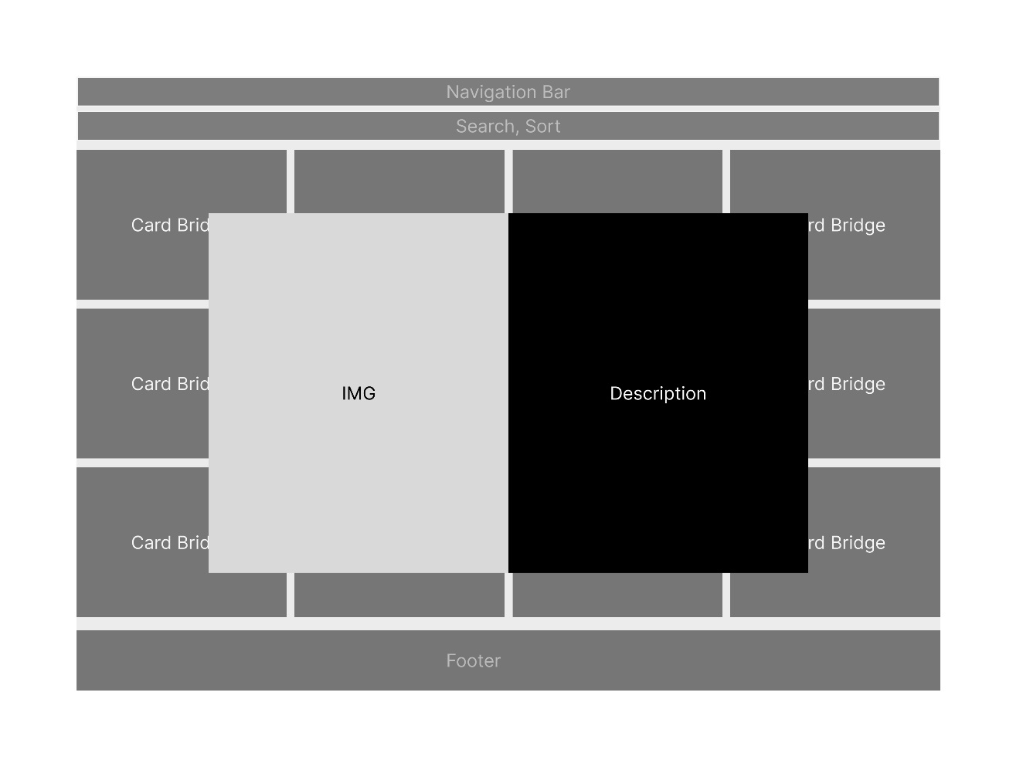

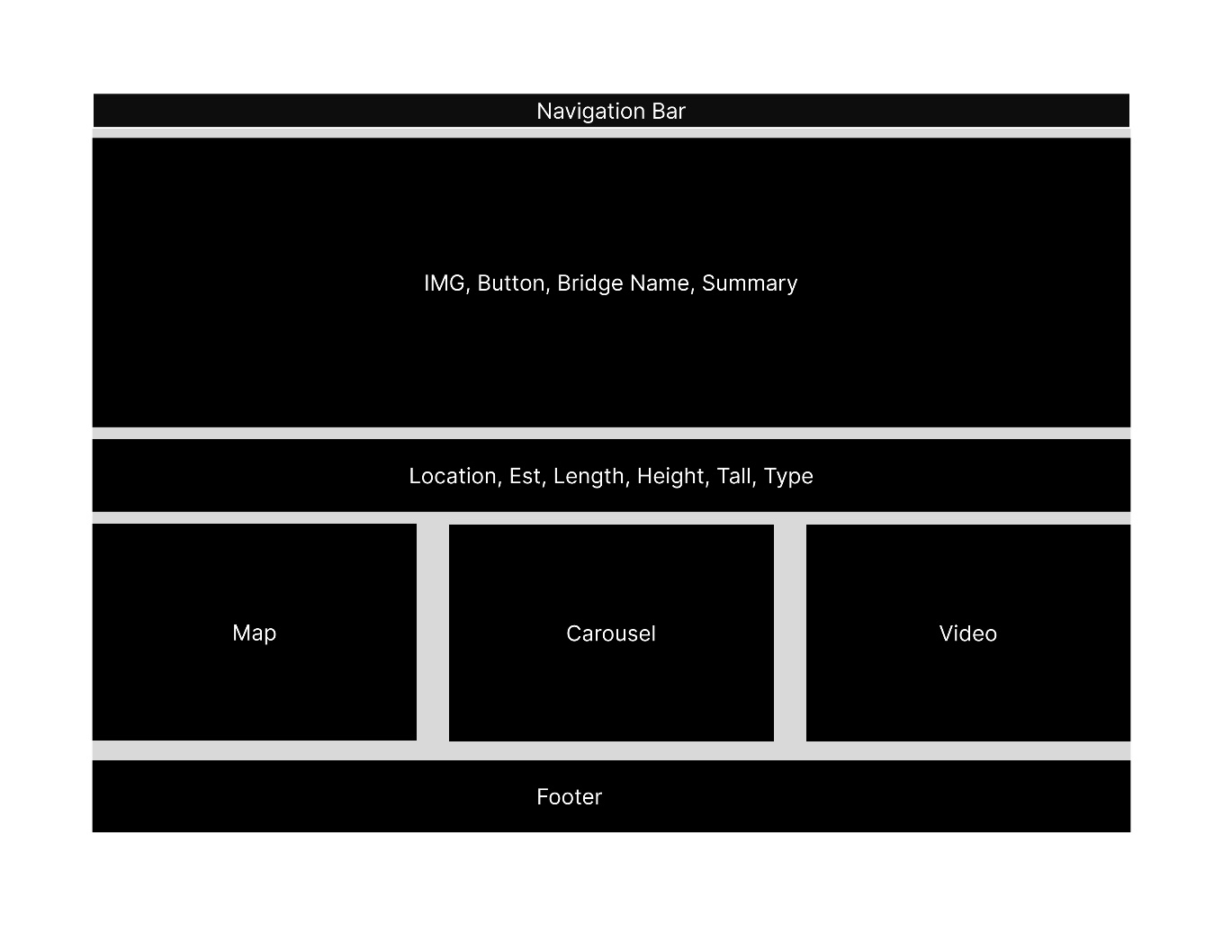

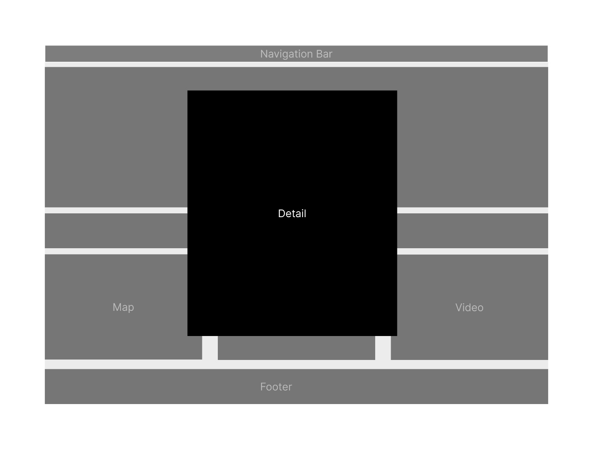

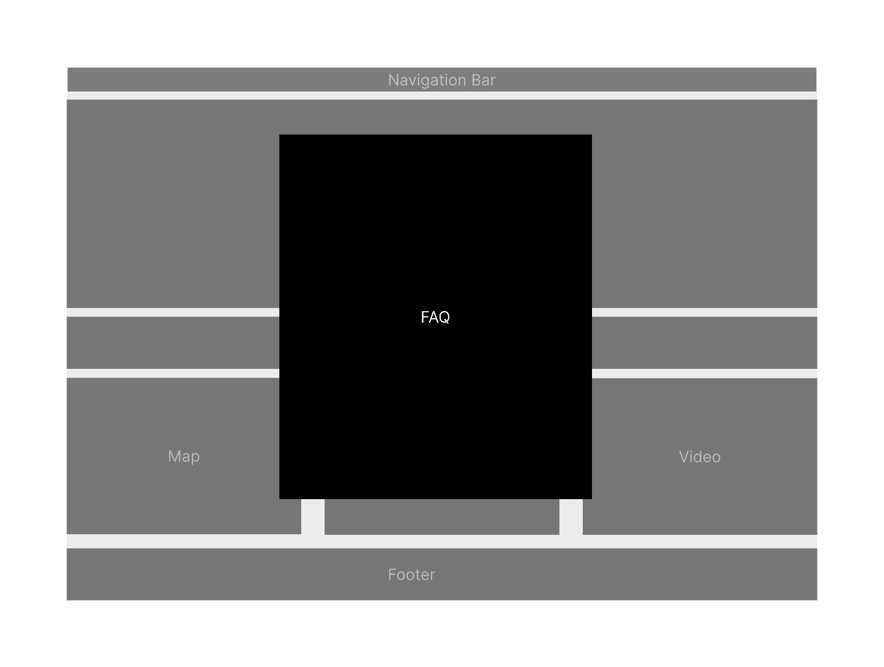

## **About Us**

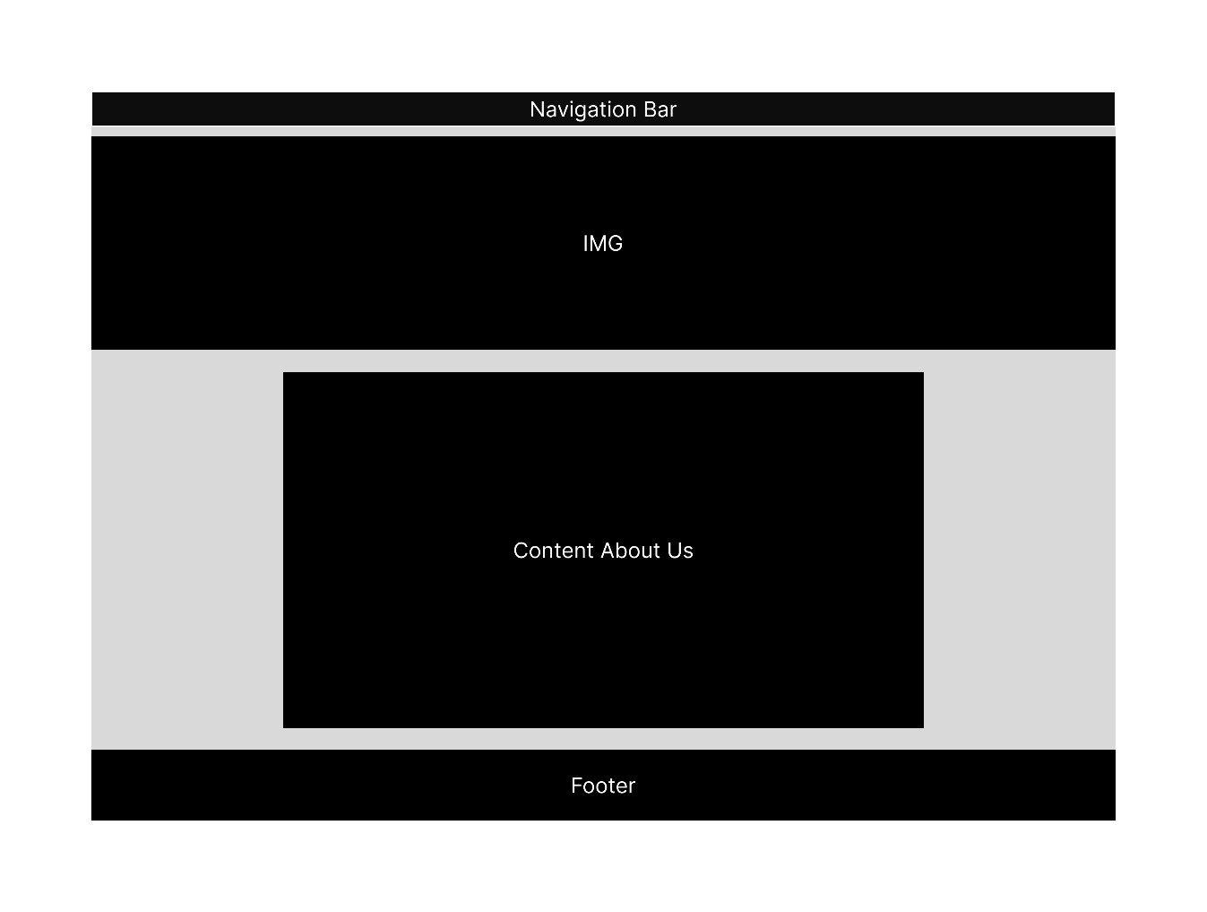

## **Feeback**

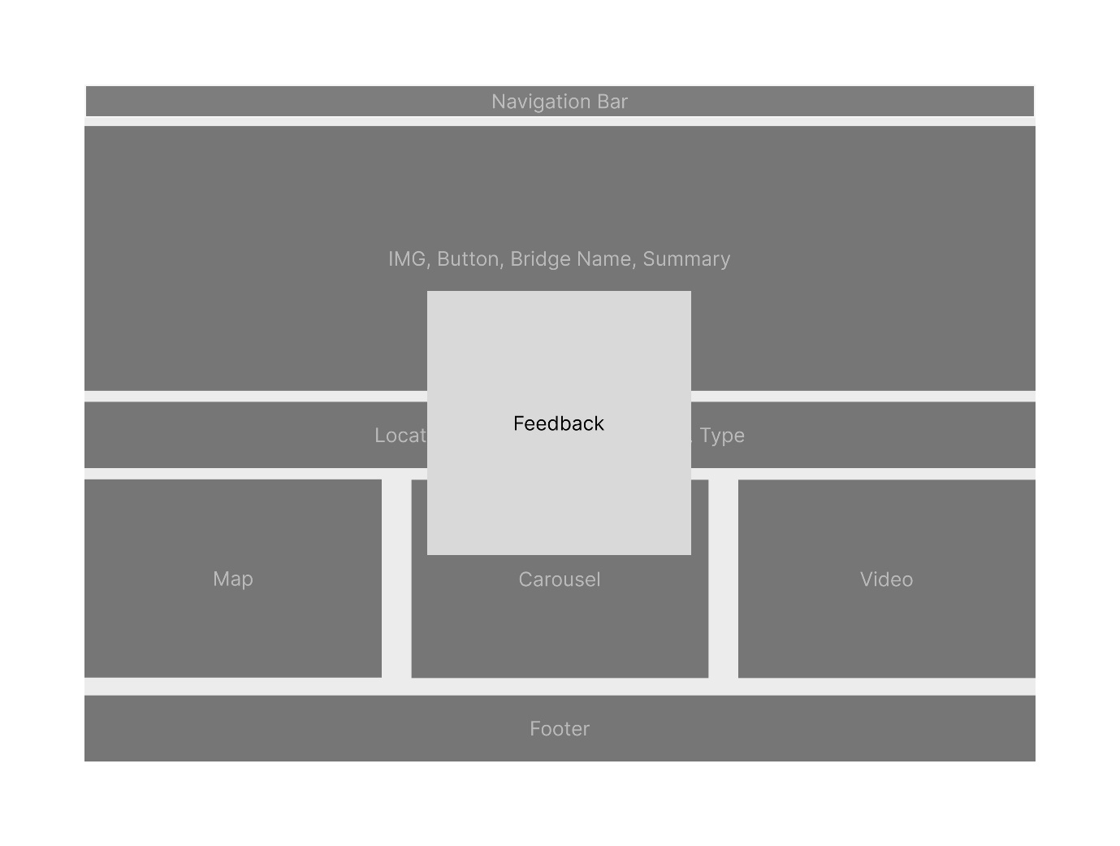

## **Gallery**

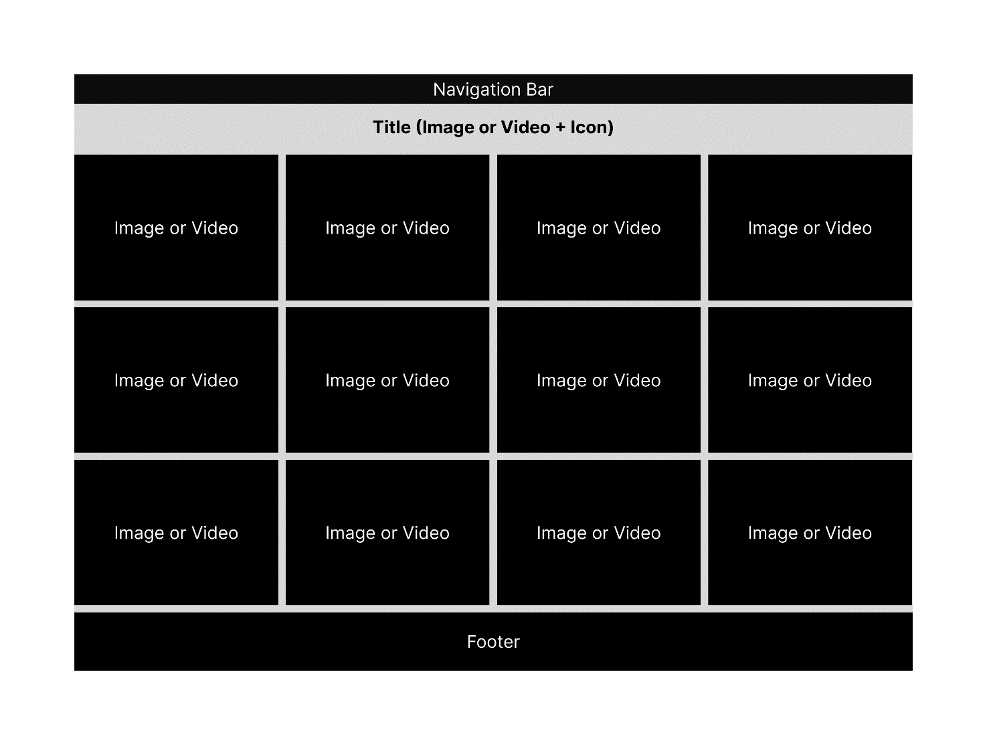

## **Site Map**

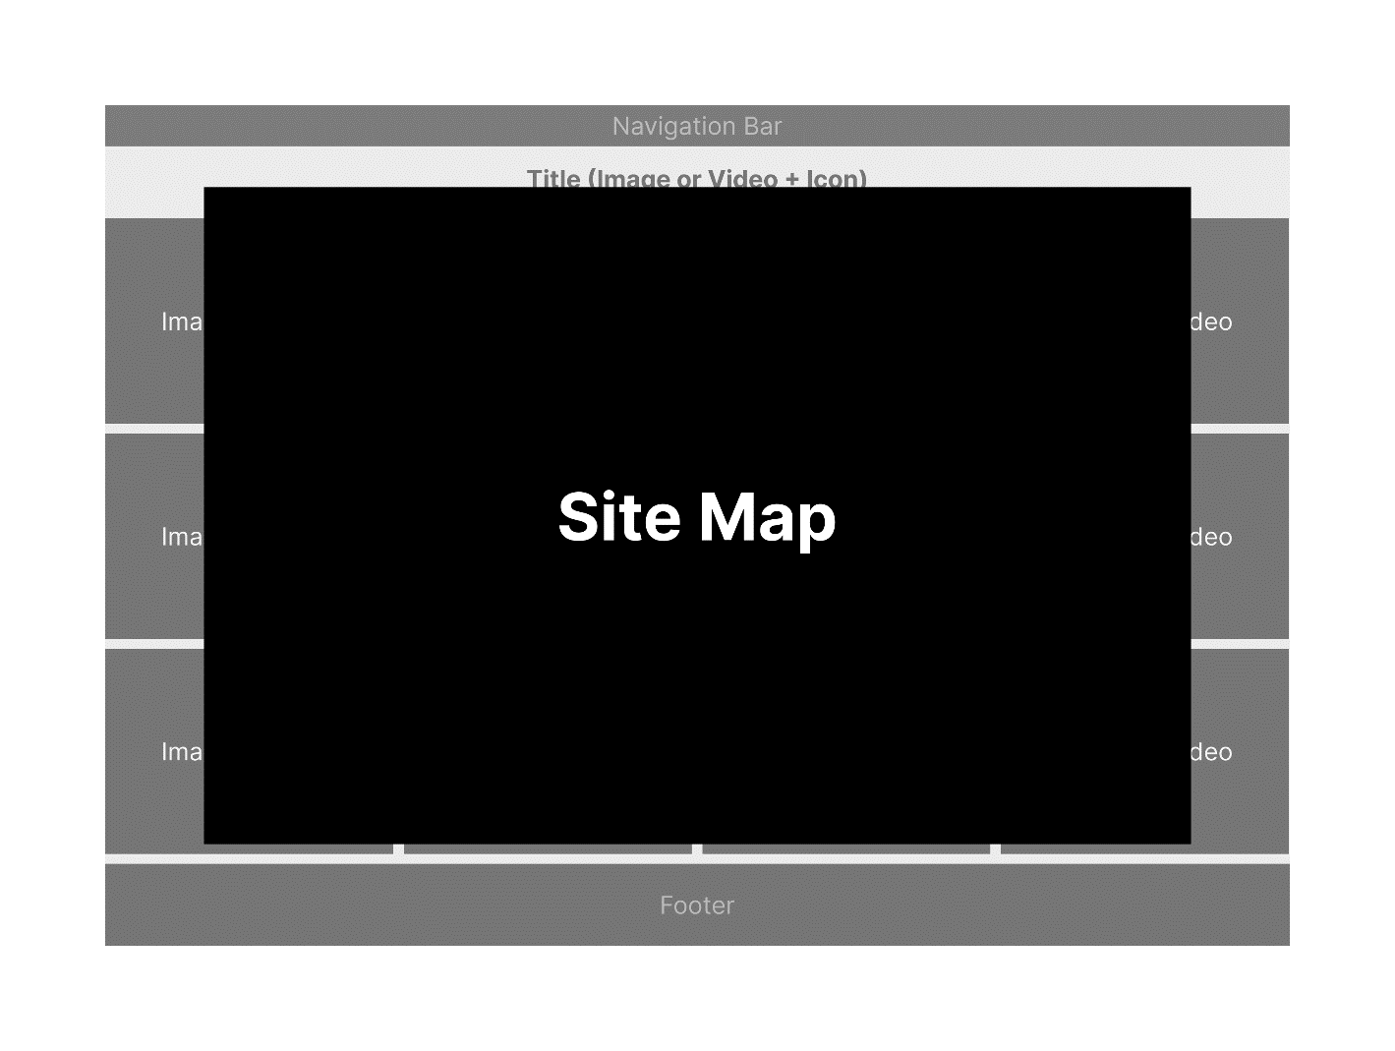

## **Contact (Pop-up Model)**

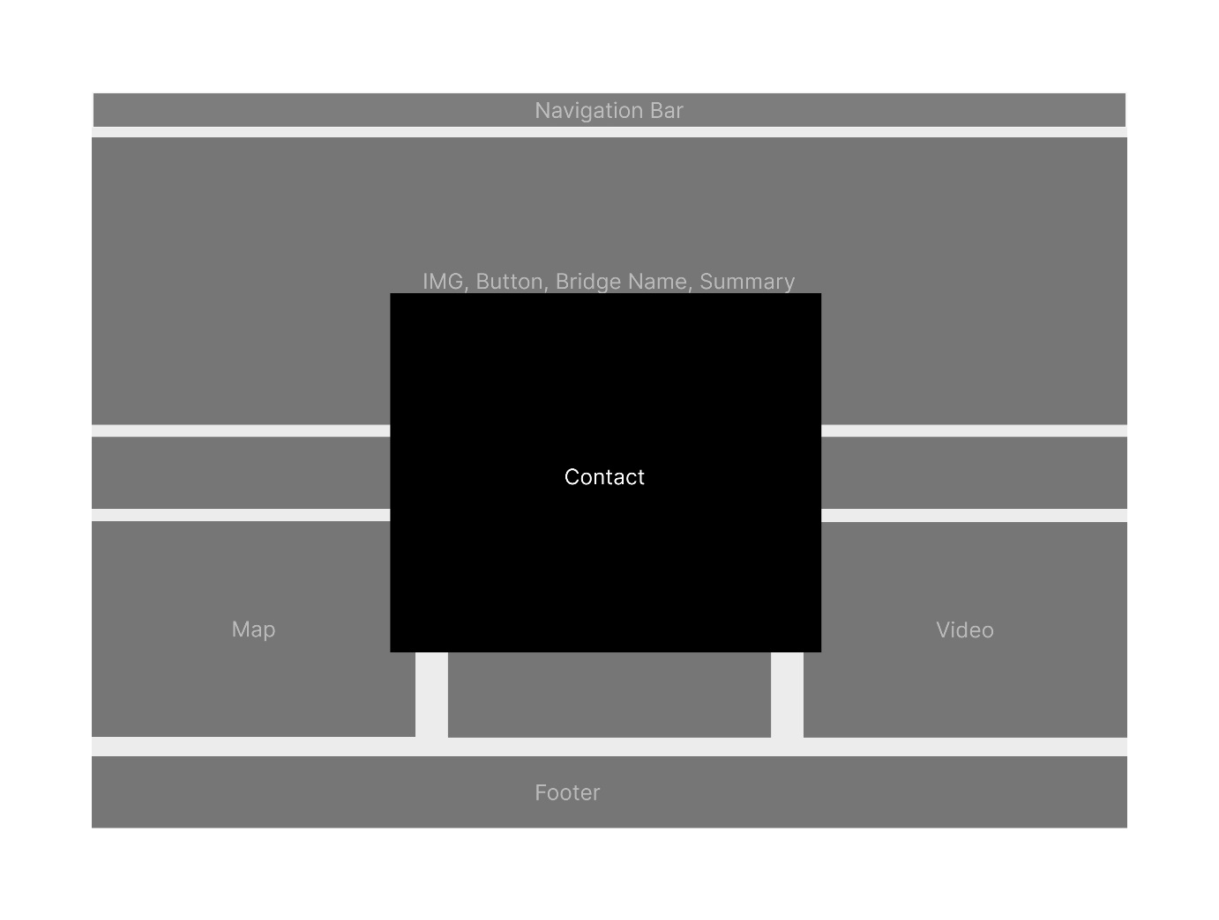

# TASK SHEET REVIEW 2

|  |  |  |  |  |  |  |  |
| --- | --- | --- | --- | --- | --- | --- | --- |
| **Project Ref. No.: eP/Advertisement Portal Management System/01** | | **Project Title:** | **Activity Plan Prepared By:** | **Date of Preparation of Activity Plan:** | | | |
| **Sr.No.** | **Task** | **Actual Start Date** | **Actual Days** | **Team Mate Names** | **Status** |
| 1 | Site map | Alpine Ascents | Thuc | 01/10/24 | 1 | Thuc | Completed |
| 2 | Mock of website | 01/10/24 | 1 | Thuc | Completed |
| 3 | Task sheet Review | 01/10/24 | 1 | Khoa | Completed |

|  |  |
| --- | --- |
| **Date: 03/10/2024** | |
| Signature of Instructor:  **Ms. Le Mong Thuy** | Signature of Team Leader:  **Nguyen Minh Thuc** |

# WEBSITE DESCRIPTION

1. **Home**  
   a) **Description:** Mankind has been building bridges since early civilizations, and today, bridges represent not only practical solutions for connection but also symbols of human ingenuity and progress. This website showcases the world's most incredible bridges, both ancient and modern, highlighting their significance in advancing both design and technology. Through these stunning feats of engineering, we celebrate the creativity and innovation that bridges embody.

b) **Screenshot:**

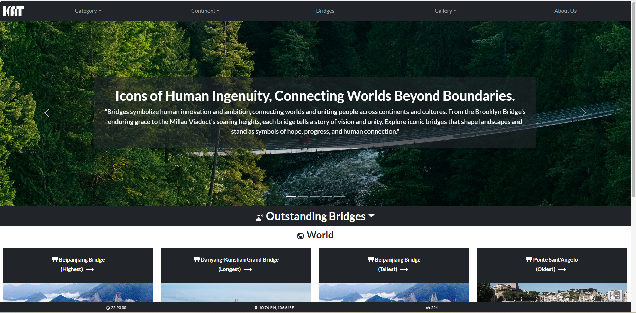

1. **Header**  
   a) **Description:** This section will always be at the top of all pages of the website. Users can easily jump to any categories at any time or return to the homepage by clicking on the menu elements they are interested in. Clicking on the logo will take the user to the homepage. Clicking on the links will direct the user to the relevant sections.

b) **Screenshot:**



1. **Top Page**  
   a) **Description:** When clicked, the website content will display at the top of the page.

b) **Screenshot:**



1. **Category**  
   a) **Description:** This section categorizes bridges into:
   * Historical Great Bridges
   * Iconic Bridges
   * Modern Great Bridges
   * High-Level Achievement Bridges

When clicked, it will illustrate the type of bridges with a search bar and sorting section.

b) **Screenshot:**

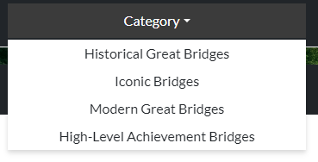

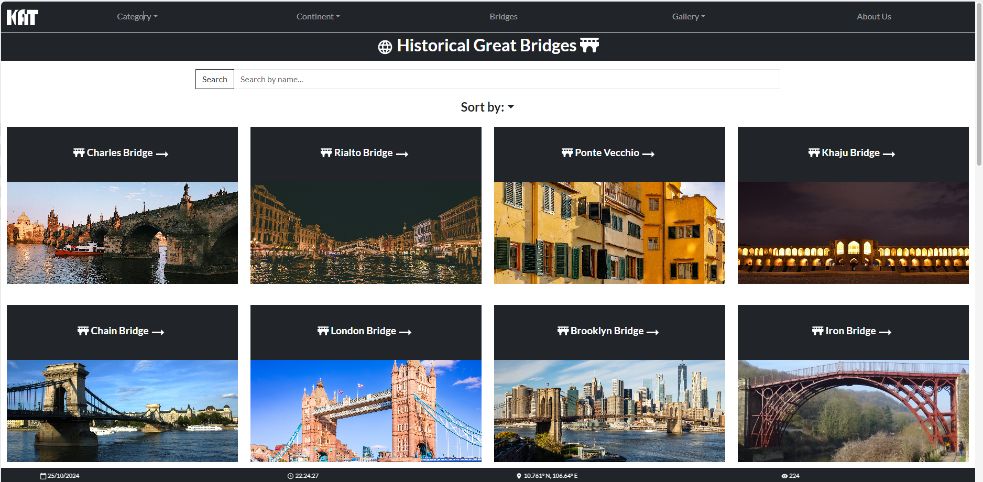

1. **Continent Filter**  
   a) **Description:** This section categorizes bridges by continents:
   * Asia
   * Europe
   * Africa
   * North America
   * South America
   * Oceania

When clicked, it will illustrate the bridges with a search bar and sorting section.

b) **Screenshot:**

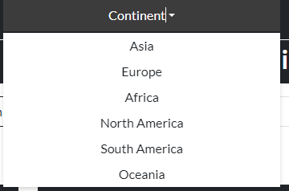

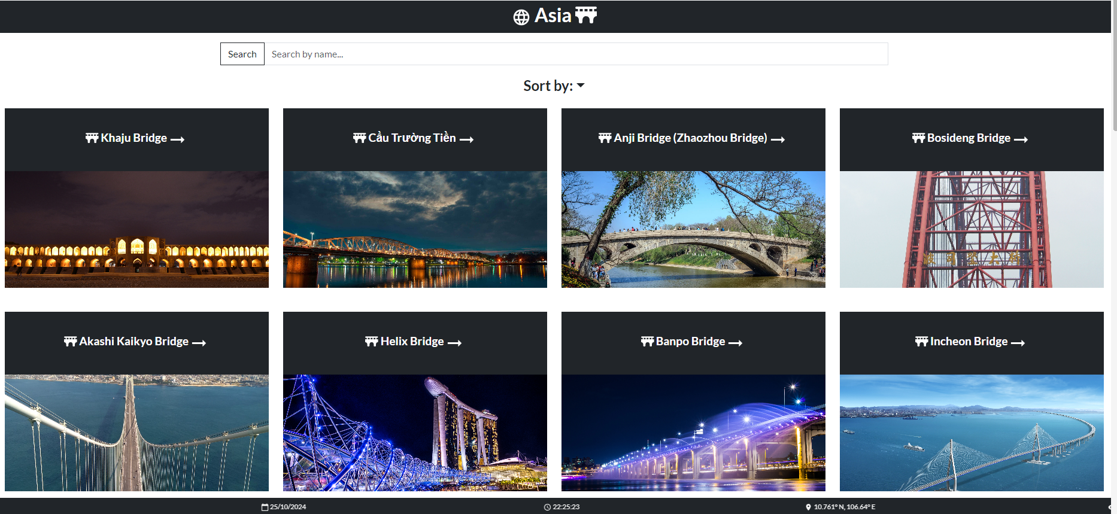

1. **List of Bridges**  
   a) **Description:** This section illustrates all the bridges with a search bar and sorting function.  
   b) **Screenshot:**

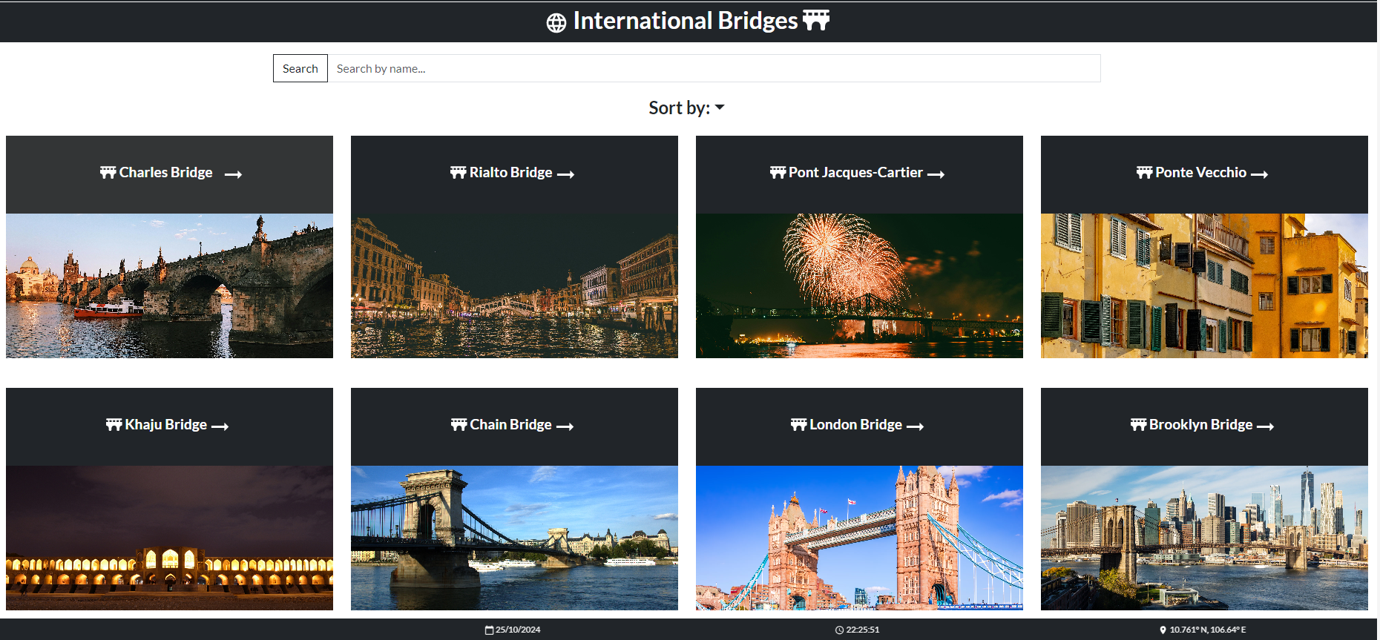

1. **Each Bridge Detail**  
   a) **Description:** When clicking on the name of the bridge on the card, a general overview of the bridge will pop up. The customer will have two options to proceed further:
   * Clicking on the 'Detail' button will take the user to another page with detailed information about the bridge (height, length, location, continent, map, video, gallery, etc.).
   * Clicking on the bridge's name or summary on the detail page will open a modal with comprehensive information about the bridge.
   * Clicking on the question mark icon on the left side of the modal will show another modal with frequently asked questions (FAQ) related to the bridge.

b) **Screenshot:**

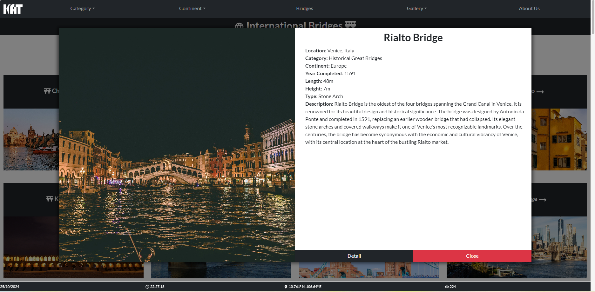

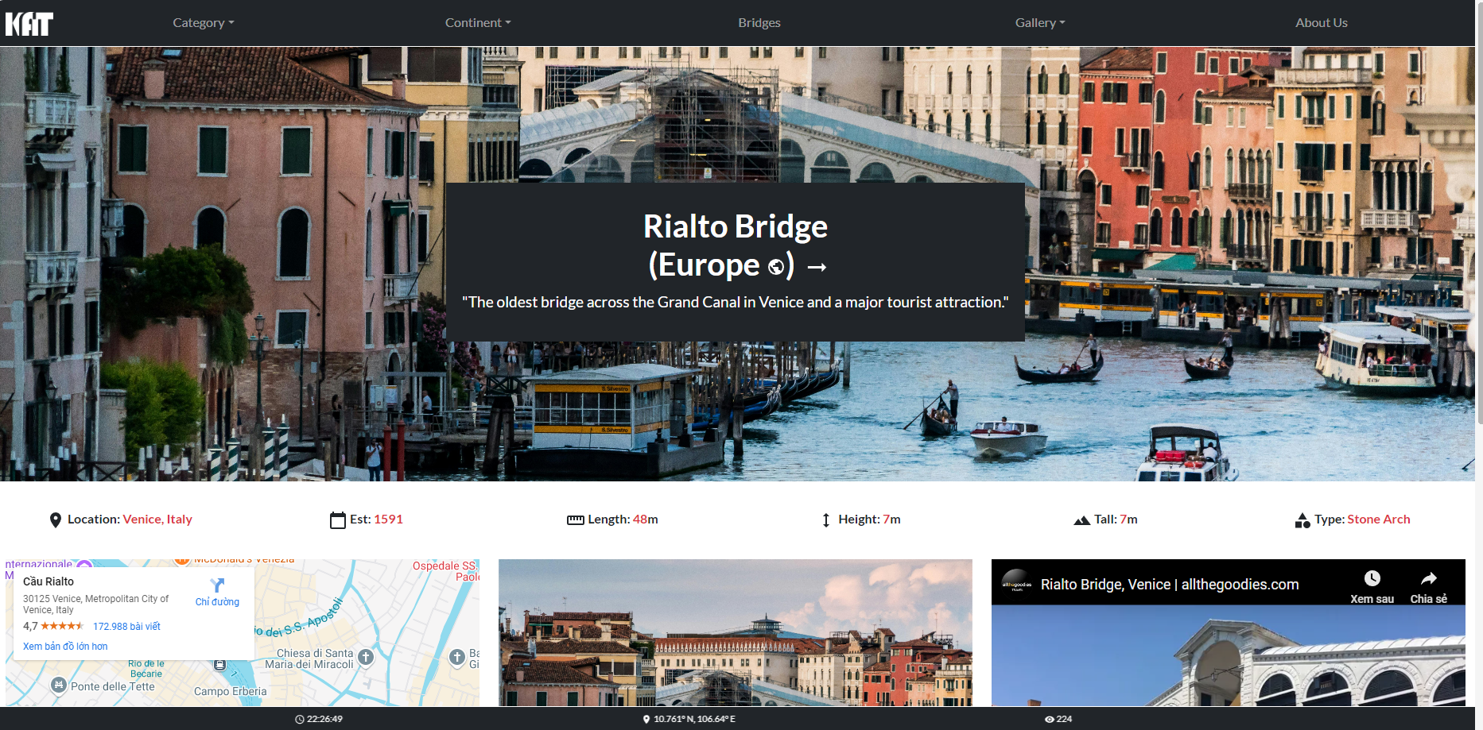

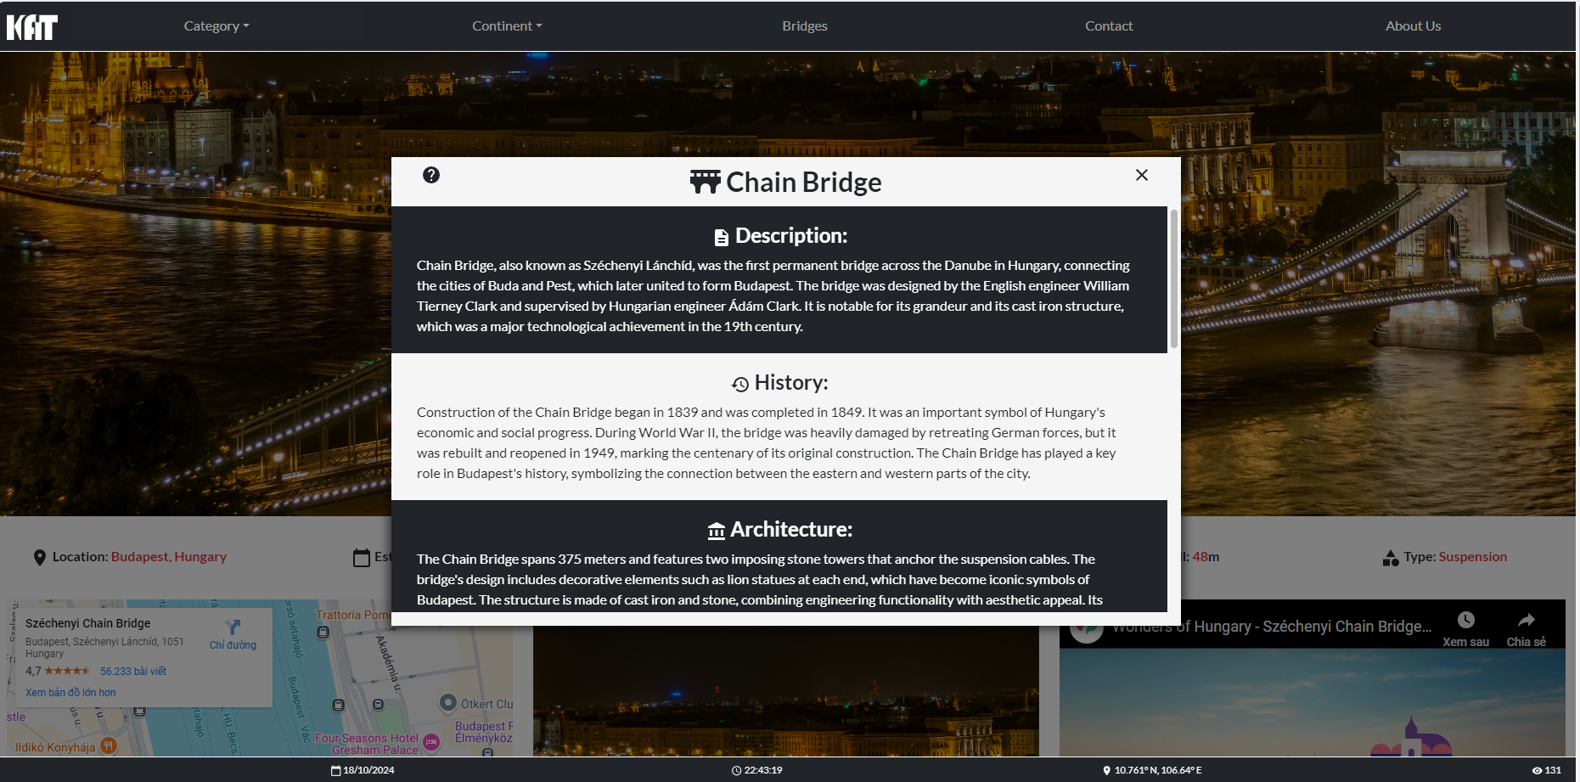

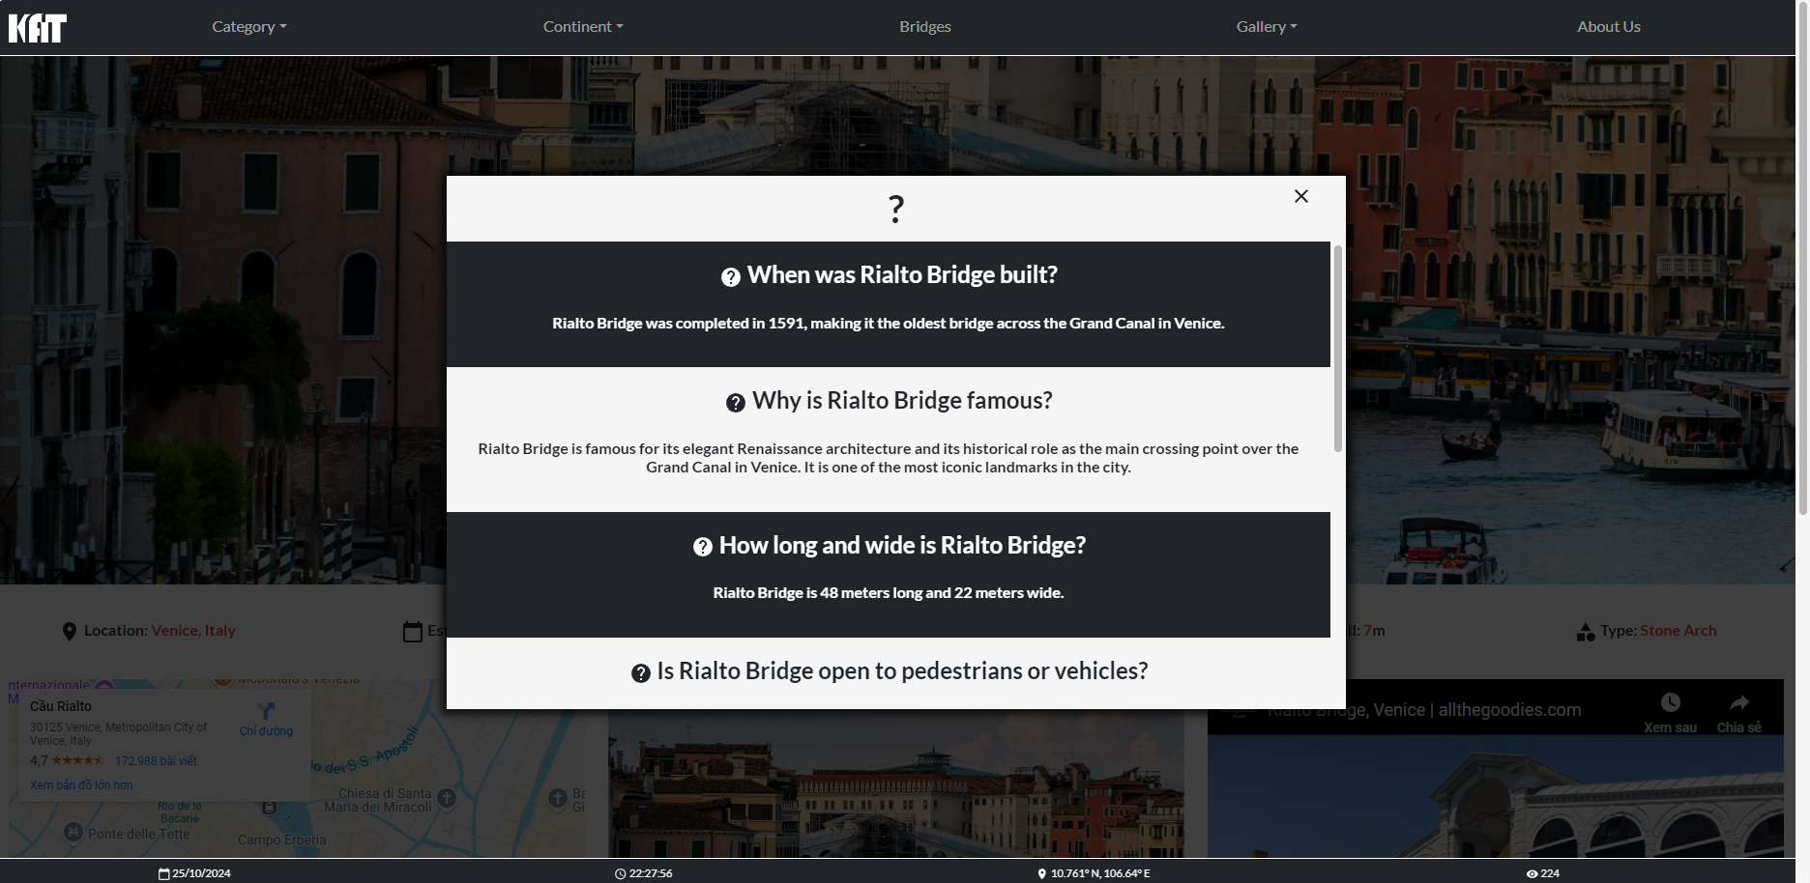

1. **Contact**  
   a) **Description:** The contact section will pop up a form for the customer to input their information for us to contact them.  
   b) **Screenshot:**

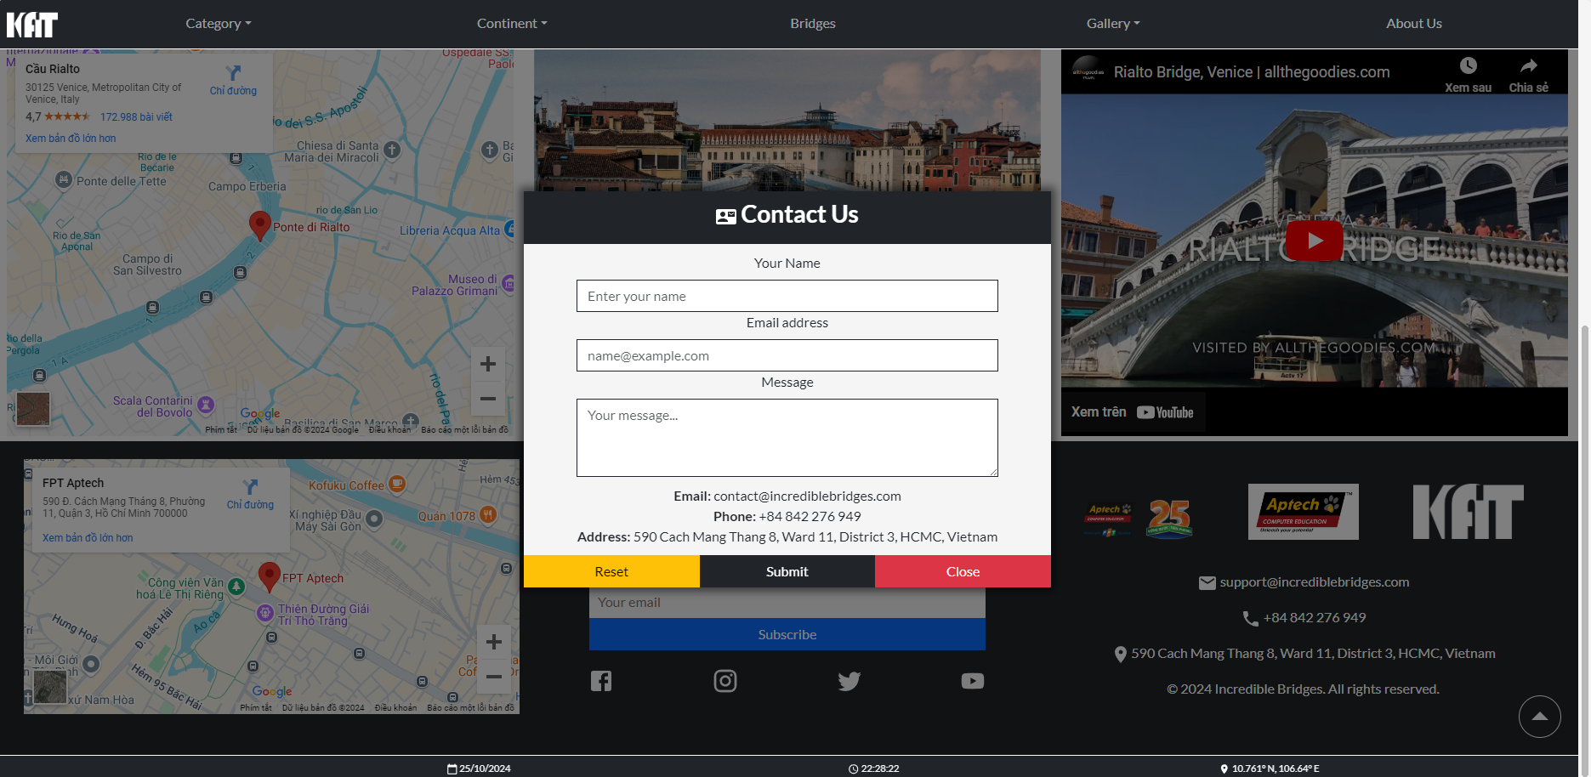

1. **About Us**  
   a) **Description:** Incredible Bridges showcases the world’s most iconic and historical bridges. Our mission is to provide an interactive platform where users can explore detailed information about these structures, including their history, architecture, and cultural significance. Led by Nguyễn Minh Thức, with Ngô Tuấn Anh handling research and Bùi Anh Khoa designing the user interface, we aim to deliver a seamless experience. Contact us at contact@incrediblebridges.com or visit us at 590 Cach Mang Thang 8, District 3, HCMC.  
   b) **Screenshot:**

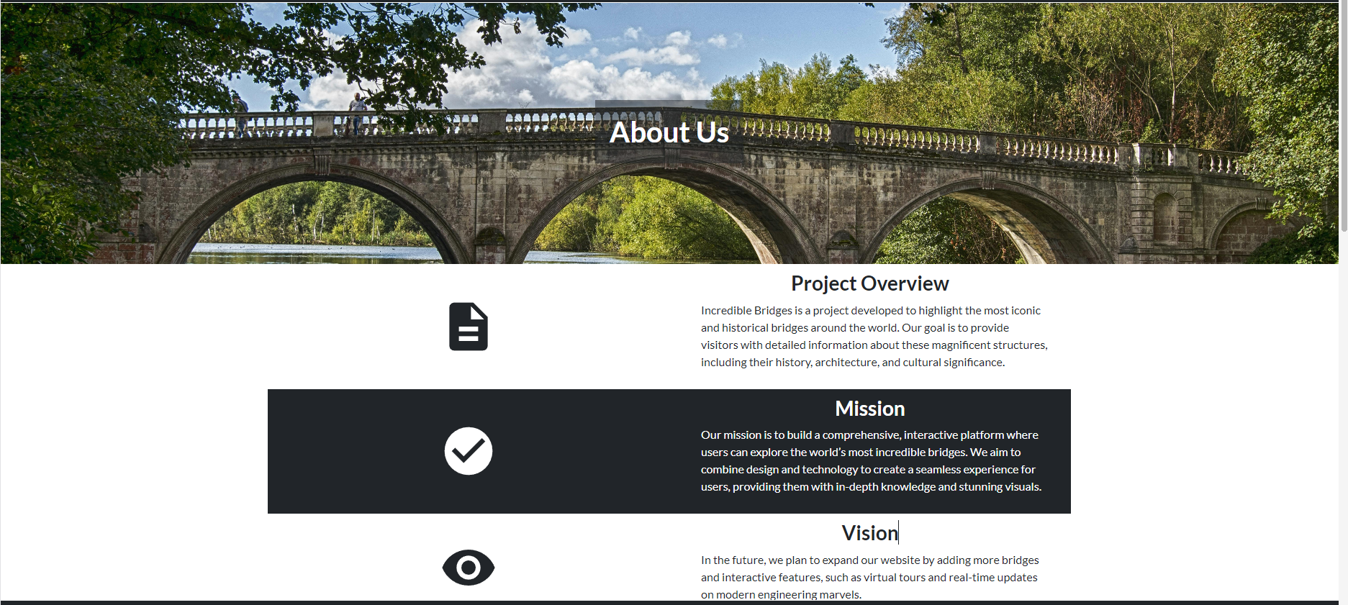

1. **Footer**  
   a) **Description:** More information about us, location, along with a site map, FAQ about the website, feedback section, newsletter subscription, links to our social media pages, links to FPT Aptech, and a Google Map showing our location.  
   b) **Screenshot:**

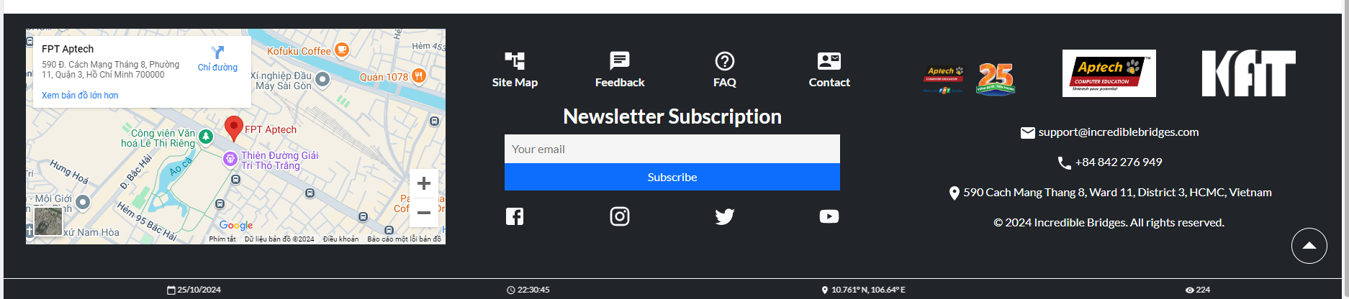

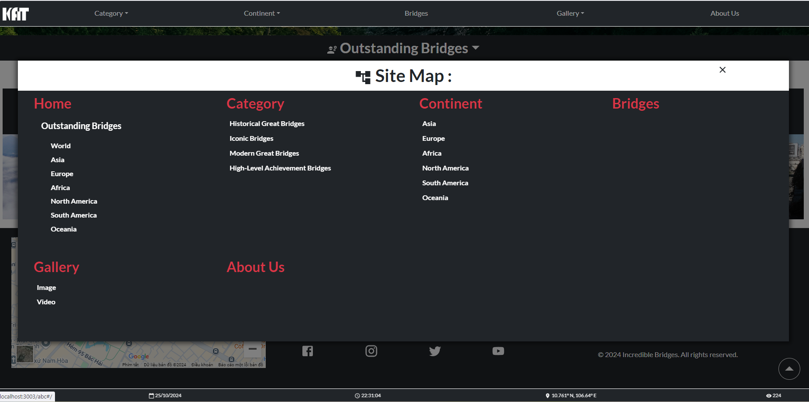

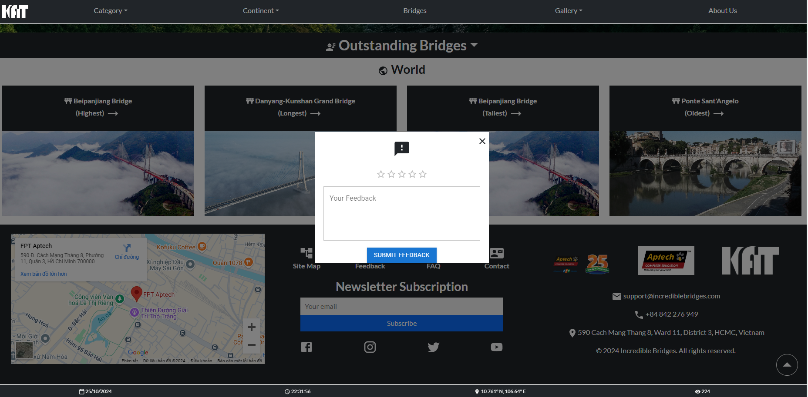

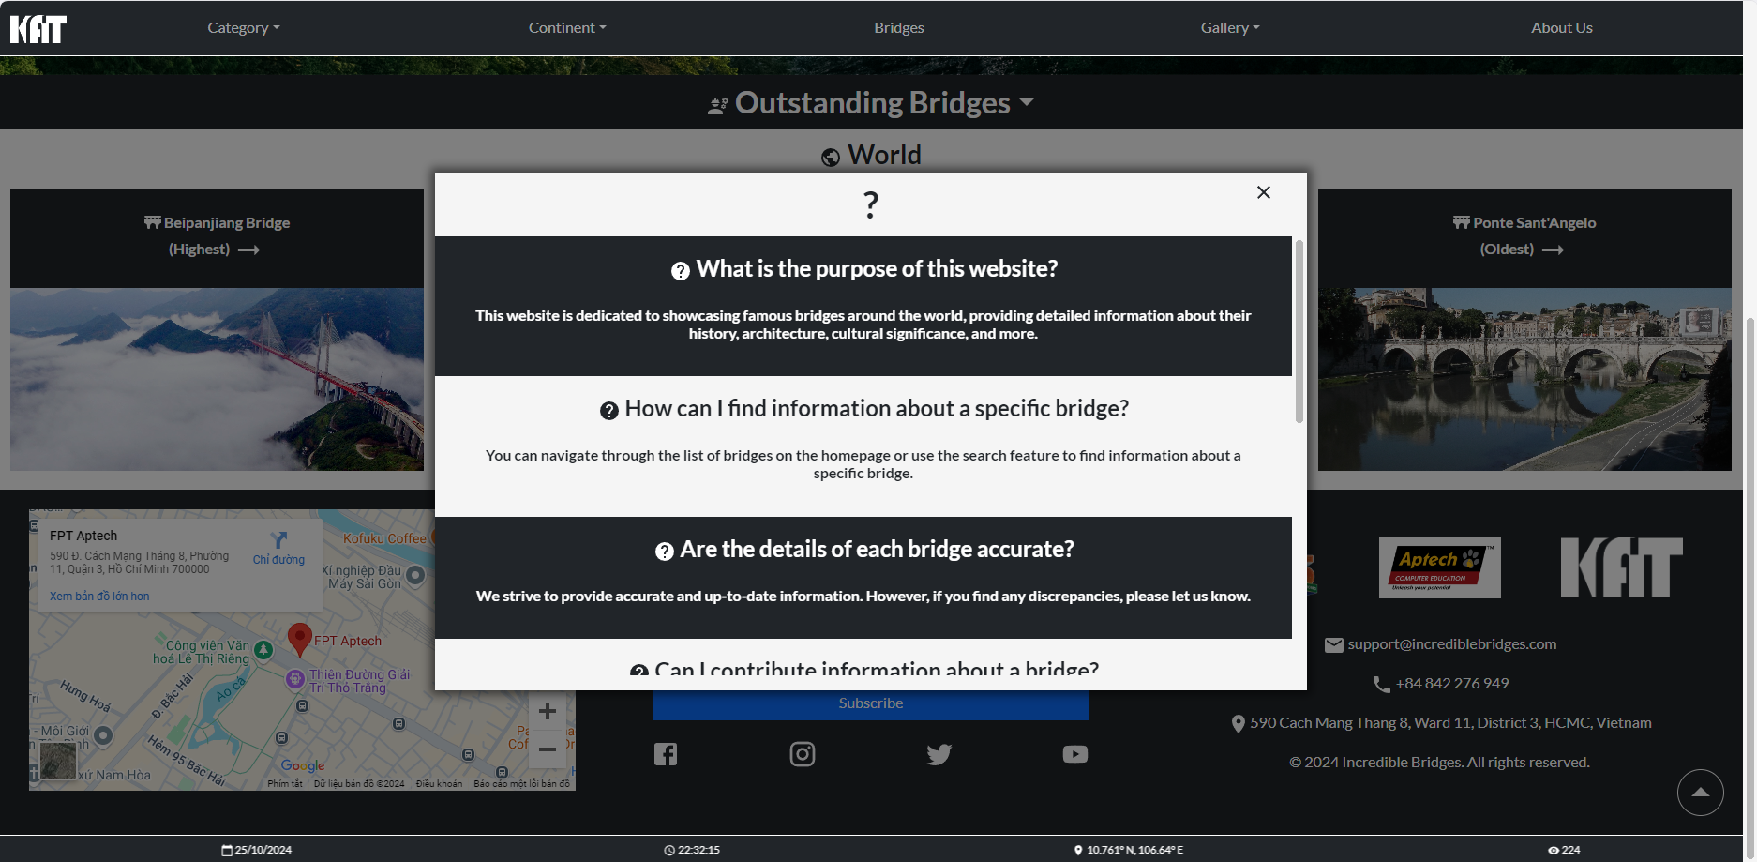

# TASK SHEET REVIEW 3

|  |  |  |  |  |  |  |  |
| --- | --- | --- | --- | --- | --- | --- | --- |
| **Project Ref. No.: eP/Advertisement Portal Management System/01** | | **Project Title:** | **Activity Plan Prepared By:** | **Date of Preparation of Activity Plan:** | | | |
| **Sr.No.** | **Task** | **Actual Start Date** | **Actual Days** | **Team Mate Names** | **Status** |
| 1 | Home | Incredible bridges | Thuc | 05/10/24 | 3 | Thức | Completed |
| 2 | Bridges |
| 3 | Continent |
| 4 | Category | 08/10/24 | 3 | Khoa | Completed |
| 5 | Contact |
| 6 | About Us |
| 7 | Feedback | 11/10/24 | 3 | Thức | Completed |
| 8 | FAQ |